TASK 1
struct Student {
let name: String
let marks: Int
let dept: String
}
let students = [
Student(name: "Asha", marks: 82, dept: "IT"),
Student(name: "Ravi", marks: 35, dept: "CSE"),
Student(name: "Meena", marks: 91, dept: "IT"),
Student(name: "Kiran", marks: 56, dept: "ECE"),
Student(name: "Divya", marks: 67, dept: "CSE"),
Student(name: "Arjun", marks: 40, dept: "IT")
]
print(students.filter { $0.marks >= 40 }.map { $0.name })
print(students.map { $0.name })
let total = students.map { $0.marks }.reduce(0, +)
print(Double(total) / Double(students.count))
print(students.sorted { $0.marks > $1.marks }.map { $0.name })
let groups = Dictionary(grouping: students, by: { $0.dept })
print(groups.keys.sorted())
print(students.filter { s in s.marks >= 40 })
print(students.filter { $0.marks >= 40 })

OUTPUT:
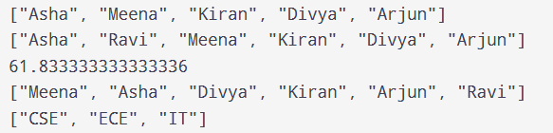
TASK 2
func myFilter(_ items: [Int], _ check: (Int) -> Bool) -> [Int] {
var result = [Int]()
for i in items {
if check(i) {
result.append(i)}}
return result
}
func applyTwice(_ value: Int, _ f: (Int) -> Int) -> Int {
return f(f(value))}
class Button {
var handlers: [() -> Void] = []
func onTap(_ action: @escaping () -> Void) {
handlers.append(action)}
func tap() {
for action in handlers {
action()
}}}
print(myFilter([1, 2, 3, 4]) { $0 > 2 })
print(applyTwice(2) { $0 * 2 })
let b = Button()
b.onTap { print("Tapped") }
b.tap()

OUTPUT:
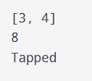
TASK 3
func makeCounter() -> () -> Int {
var count = 0
return {
count += 1
return count
}
}
let a = makeCounter()
let b = makeCounter()
print(a(), a(), b(), a())

OUTPUT:
